ST0501 FRONT-END WEB DEVELOPMENT
INDIVIDUAL CA2 REFLECTION JOURNAL

Student Name: ZHANG YUXI Admin Number: P2617802
Class: DCITP/FT/1A/04 Group No: 4

Objective :
This Reflection Journal requires you to critically analyze your CA2 project decisions, technical issues, and your responsible use of AI tools. Tutors are looking for depth of thought and examples that demonstrate understanding of your work.
Instructions:
- Answer all 3 parts below
- Total word count : 900-1200 words
- Use examples from your CA2 or class activities where relevant
- Submitted individually via BrightSpace.
- Attach your AI prompt logs using the Academic Integrity Declaration link (available in BrightSpace) in Appendix, this will not be included in the wordcount.

Part 1: Reflection on Styling Frameworks & Interactivity
- What changes are made to the original plan? Why are the changes necessary? And what impact do they cause e.g on the website, user experience, performance etc?
- Analyze the trade-offs between using a front-end styling framework (e.g., Bootstrap/Tailwind) and writing custom CSS in your project. How did your choice affect the efficiency, design flexibility, or maintainability of your website?
- Evaluate one interactive feature (e.g., form validation, DOM update, dynamic menu) you implemented: How well does it improve user experience? If you had to enhance it further, what changes would you make and why?

Word Count Suggestion: 250-450 words. (Write your answer here)

Our original plan was to write custom CSS from scratch to let our website look the most unique. However, as development progressed, we realized that building complex responsive layouts manually was time-consuming and not consistent for pc and mobile layouts. To fix this, we shifted our strategy to incorporate Bootstrap as our framework.

Our group chose Bootstrap as our main framework because it has many pre-created templates which would allow us to build interactive and responsive pages quickly. The templates did make our lives easier, but it has limited customization. Hence, we used custom CSS to make changes such as Logos and colours. All of these increased our progress efficiency and made the codes more organized. Hence, Bootstrap and our own custom CSS allowed our website to remain unique and neat despite using some pre-made templates.

One interactive feature we implemented was flashcards. These buttons allowed users to interact with information in a fun way instead of only viewing static information. The flashcards improved the user experience because users could access additional through a simple click. This made the website more engaging and easier to use. It also made the website feel more interactive rather than just being a collection of information. If I were to improve the feature further, I would make the buttons provide clearer visual feedback when users interact with them.

Part 2: Reflection on JavaScript & DOM Interactivity
- What changes are made to the original plan? Why are the changes necessary? And what impact do they cause e.g on the website, user experience, performance etc?
- Which JavaScript feature you added (e.g., image gallery, menu toggle, validation) made the biggest impact on your website’s user experience? Why?
- Think about the form your created in CA2 or practiced in class: What makes a form easy or hard for users to complete? What is one improvement you would suggest making a form more user-friendly, and why?

Word Count Suggestion: 250-450 words. (Write your answer here)

Our original plan was to include JavaScript features like buttons and some more advanced functions to make the website interactive. During development, we encountered problems where some of our interactive features did not work properly. Because of this, we had to spend additional time debugging the JavaScript and checking how it connected to our HTML elements, as well as replacing some of the more difficult features with easier ones to ensure that the website works.

The changes were necessary because the interactive features were an important part of our website. If the features do not work, users would not be able to access certain features properly. Fixing the JavaScript improved the functionality and user experience of the website.

A form can become difficult to complete when there are unclear instructions, too many unnecessary fields or confusing error messages. One improvement I would suggest is adding clear validation messages. For example, if a user leaves a required field empty, the form should clearly explain that the field needs to be completed. This would help users identify their mistakes quickly instead of having to search through the entire form.

Part 3: Reflection on AI Usage and Evidence of Understanding

- Analyze your use of AI during this project: Which specific problem or task did AI help you with, and why did you choose to use AI for it?
- Choose one example where you used AI to help with coding for your website. Show the original AI-generated snippet and your modified version. Explain what you changed and why. How did your changes make the code better or fit your project needs?

Word Count Suggestion: 250-450 words. (Write your answer here)
During this project, I used AI to assist me in coding issues in the HTML, CSS and JavaScript component. Due to the errors, I made in the complex code being difficult and confusing. Hence, I used AI to assist me in fixing the issues in the code.
I mainly used AI to ask about the errors in my webpage, as the problem could be related to the JavaScript itself, the HTML elements, the page links, the element IDs or the event listeners. AI helped me identify possible causes of the problem and suggested ways that I could investigate and fix it.
However, I did not simply copy the AI's answer without checking it. I had to understand the suggested changes and determine whether they were suitable for my website. This was important because AI-generated code may not always match the structure or requirements of my project.

One example is when my webpage was duplicated twice in the page, I had no idea what was causing it and could not fix it. Hence, I used AI to determine what was wrong. The AI correctly identified that the issue was my HTML being linked to the wrong JavaScript page.
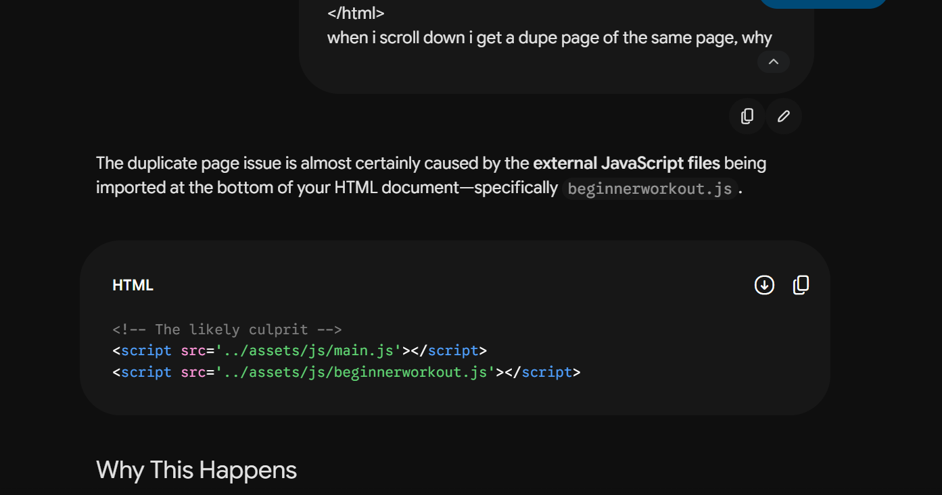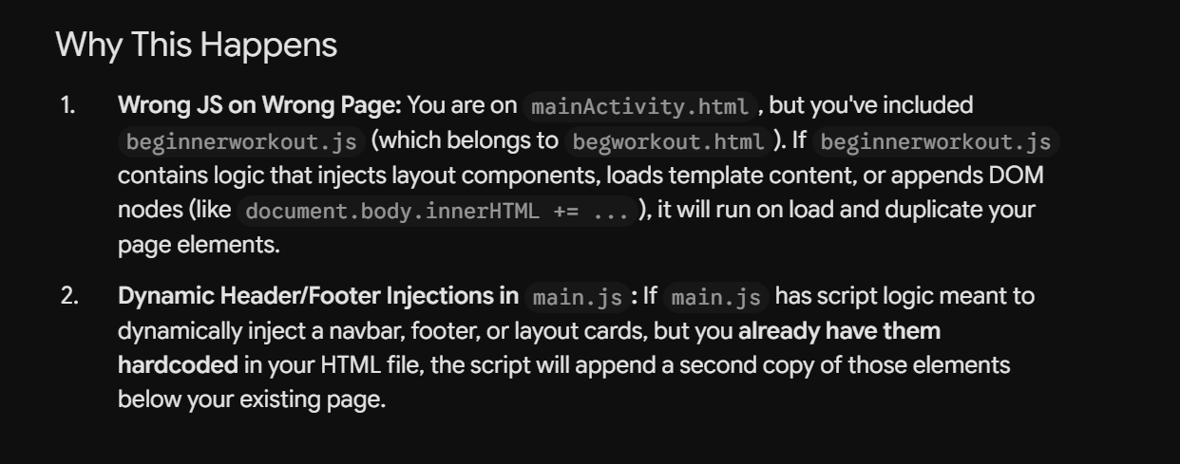

Appendix (e.g AI outputs or evidences you would like to include, this will not be included in the wordcount)

~~ The End ~~

